# Filtering & Categorization

1. **Filter by keyword should be added**
   * **Issue**: Users can’t search tenders by specific terms (e.g. “ICT”, “construction”).
   * **Impact**: Limits discoverability and slows down navigation.
   * **Solution**: Implement a dynamic search bar with real-time filtering across tender titles, descriptions, and tags. Use fuzzy matching to catch typos and synonyms.
2. **Filter by date doesn’t work for only one day**
   * **Issue**: Selecting a single date (e.g. July 9) doesn’t return results.
   * **Impact**: Users can’t pinpoint tenders posted or closing on a specific day.
   * **Solution**: Fix the date picker logic to allow single-day queries. Ensure backend supports startDate = endDate filtering.
3. **Enhanced Date Filter Options**
   * Issue: Users lack control over whether they’re filtering by when a tender was posted or when it’s due.
   * Impact: Limits the usefulness of date filters, especially for time-sensitive bid planning or tracking newly announced tenders.
   * Solution: Add a toggle to switch between filtering by **Posted Date** and **Deadline**, and ensure both fields are indexed and queryable to support precise date-based results.
4. **In filter category display, the category should contain section and subsection**
   * **Issue**: Categories are flat and lack hierarchy.
   * **Impact**: Users can’t drill down into specific areas (e.g. “Construction > Roads”).
   * **Solution**: Introduce nested categories using a tree structure. This improves clarity and supports better filtering.
5. **Category should be in alphabetical order**
   * **Issue**: Categories are randomly ordered.
   * **Impact**: Users struggle to locate familiar categories.
   * **Solution**: Sort categories alphabetically client-side for consistency and ease of use.

# Video Playback

1. **Video doesn’t work to see GetChereta in action**
   * **Issue**: Demo video fails to load or play.
   * **Impact**: Users miss out on understanding platform features.
   * **Root Causes**: Could be format incompatibility, broken link, or hosting issues2.
   * **Solution**:
     + Re-upload in MP4 format with H.264 encoding.
     + Host on a reliable platform like YouTube or Vimeo.
     + Test across browsers and devices.

# Quick Access Features

1. **AI Proposal, AI Win Rate, AI Document Chat, and AI Summary should allow users to upload a document**
   * **Issue**: These features show “You don’t have any file” without an upload option.
   * **Impact**: Users can’t initiate AI workflows.
   * **Solution**:
     + Add a clear “Upload Document” button.
     + Use conditional rendering: if no file exists, show upload prompt instead of empty state.
2. Reporting & Analytics in Quick Access Panel
   * **Issue:** The Quick Access section lacks reporting and analytics features such as bid posted today, bid closed today, active bids, and total bids on the platform.
   * **Impact:** Users have limited visibility into platform activity, making it harder to track performance, plan submissions, or assess market engagement.
   * **Solution:** Add a reporting dashboard that displays real-time metrics including bids posted today, bids closed today, active bids, and cumulative bid totals

# Tender Integration

1. **Tenders from eGP Ethiopia should be posted**
   * **Issue**: GetChereta lacks integration with Ethiopia’s official eGP portal.
   * **Impact**: Users miss out on verified government tenders.
   * **Solution**:
     + Use eGP’s public API or RSS feed to sync tenders.
     + Ensure metadata (title, deadline, procuring entity) is mapped correctly.

# Personal Information & Password

1. **12 characters for password is too long**
   * **Issue**: Minimum password length is excessive.
   * **Impact**: Frustrates users during signup.
   * **Solution**: Reduce to 8 characters with complexity rules (uppercase, number, symbol).
2. **Show Password option should be included**
   * **Issue**: Users can’t view what they’re typing.
   * **Impact**: Increases login errors.
   * **Solution**: Add a “👁 Show Password” toggle to input fields.

# UI/UX

1. **UI/UX is not attractive and easy to navigate (2Merkato’s is very good)**

* **Issue**: Current interface is cluttered or unintuitive.
* **Impact**: Users struggle to post bids or find tenders.
* **Reference**: 2Merkato’s tender interface is praised for clarity and simplicity.
* **Solution**:
  + Adopt a card-based layout with clear CTAs.
  + Use progressive disclosure (show details only when needed).
  + Consider temporarily mirroring 2Merkato’s structure while redesigning.
  + Reference: <https://tender.2merkato.com/start>

1. Bid Notification Layout & Functionality

* **Issue:** The bid notification layout is unclear and lacks structured formatting, making it difficult for users to quickly identify key information such as title, deadline, and buyer.
* **Impact:** Users may overlook critical bid opportunities or spend unnecessary time parsing through unorganized details.
* **Solution:** Redesign the bid notification format with a clear header (title), metadata (posting date, deadline, posted date (on news paper))
* **Sample:**
* 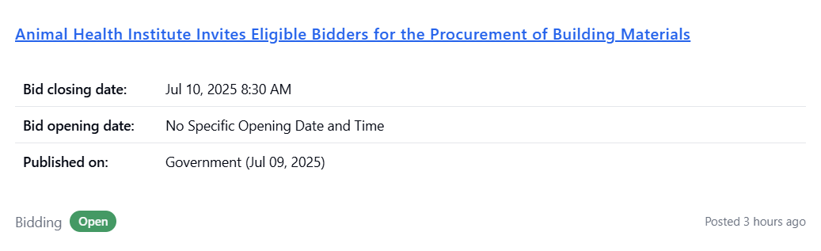

# Exchange Rate Functionality

1. **Exchange rate is not working**

* **Issue**: Rates fail to load or display outdated data.
* **Impact**: Users can’t make informed financial decisions.
* **Solution**:
  + Sync with reliable sources like EthioXchange or Commercial Bank of Ethiopia.
  + Cache fallback values and show last updated timestamp.

# Bid Document Upload

1. **Bid Document Upload is not working**

* **Issue**: Uploads fail silently or throw errors.
* **Impact**: Blocks bid submission.
* **Solution**:
  + Check file size limits, format restrictions, and storage configuration.
  + Add clear error messages and progress indicators.

# Dashboard as Landing Page

1. **Bring the dashboard to the landing page**

* **Issue**: Users land on a generic homepage.
* **Impact**: Adds friction to accessing dashboard.
* **Solution**:
  + Make dashboard the default post-login view.
  + Include widgets for “New Tenders”, “My Bids”, “AI Insights”, and “Upload Center”.

# Bid Notification Features

1. **Export Bid Notifications**

* **Issue**: Users cannot export or download bid notifications for external use.
* **Impact**: Restricts reporting, offline archiving, and integration with productivity tools.
* **Solution**: Introduce export options (CSV, Excel, PDF), with filters for date, category, and status to support batch reporting and customized downloads.

1. **Save Bid Notifications**

* **Issue**: There’s no way to bookmark or save bid alerts for later reference.
* **Impact**: Users lose track of tenders they want to monitor or revisit.
* **Solution**: Add a “Save Notification” feature that bookmarks bid alerts to a user-specific dashboard, with tagging and categorization for better organization.

1. **Notification History View**

* **Issue**: Users can’t view previously received bid notifications.
* **Impact**: Reduces continuity in bid monitoring and long-term tracking.
* **Solution**: Create a “Saved Bids” history panel with filters for saved bids.